4-Wheel Arduino Robot Project

Project Description
This project tests a 4-wheel DC robot using an Arduino and L298N motor driver. The robot performs forward, backward, left, and right movements, then follows a square path using delay-based timing without sensors or PID control.

Components Used
- Arduino UNO or Nano
- L298N Motor Driver
- 4 DC Motors
- Robot Chassis
- Battery Pack
- Jumper Wires
- Optional Relay Module (future water pump control)

Pin Mapping
L298N Pin | Arduino Pin | Purpose
IN1 | 8 | Left motor direction
IN2 | 9 | Left motor direction
IN3 | 10 | Right motor direction
IN4 | 11 | Right motor direction
ENA | 5 | Left motor speed PWM
ENB | 6 | Right motor speed PWM
Relay | 7 | Reserved water pump relay

Circuit Diagram
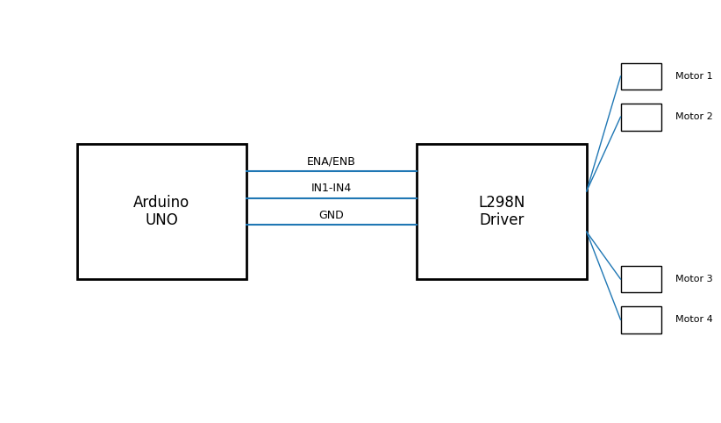

Arduino Code
/*
4-Wheel Robot Test using Arduino + L298N
*/
const int IN1 = 8;
const int IN2 = 9;
const int IN3 = 10;
const int IN4 = 11;
const int ENA = 5;
const int ENB = 6;
const int relay_pin = 7; // Reserved for water pump
int motorSpeed = 200;
void setup() {
pinMode(IN1, OUTPUT);
pinMode(IN2, OUTPUT);
pinMode(IN3, OUTPUT);
pinMode(IN4, OUTPUT);
pinMode(ENA, OUTPUT);
pinMode(ENB, OUTPUT);
pinMode(relay_pin, OUTPUT);
digitalWrite(relay_pin, LOW);
analogWrite(ENA, motorSpeed);
analogWrite(ENB, motorSpeed);
delay(2000);
moveForward();
delay(3000);
stopMotors();
delay(1000);
moveBackward();
delay(3000);
stopMotors();
delay(1000);
turnLeft();
delay(3000);
stopMotors();
delay(1000);
turnRight();
delay(3000);
stopMotors();
delay(2000);
}
void loop() {
for (int i = 0; i < 4; i++) {
moveForward();
delay(3000);
stopMotors();
delay(500);
turnLeft();
delay(700);
stopMotors();
delay(500);
}
stopMotors();
while (true);
}
void moveForward() {
digitalWrite(IN1, HIGH);
digitalWrite(IN2, LOW);
digitalWrite(IN3, HIGH);
digitalWrite(IN4, LOW);
}
void moveBackward() {
digitalWrite(IN1, LOW);
digitalWrite(IN2, HIGH);
digitalWrite(IN3, LOW);
digitalWrite(IN4, HIGH);
}
void turnLeft() {
digitalWrite(IN1, LOW);
digitalWrite(IN2, HIGH);
digitalWrite(IN3, HIGH);
digitalWrite(IN4, LOW);
}
void turnRight() {
digitalWrite(IN1, HIGH);
digitalWrite(IN2, LOW);
digitalWrite(IN3, LOW);
digitalWrite(IN4, HIGH);
}
void stopMotors() {
digitalWrite(IN1, LOW);
digitalWrite(IN2, LOW);
digitalWrite(IN3, LOW);
digitalWrite(IN4, LOW);
}

Movement Logic
Forward: Both left and right motors rotate forward.
Backward: Both left and right motors rotate backward.
Left Turn: Left motors backward and right motors forward.
Right Turn: Left motors forward and right motors backward.
Square Path: Move forward for 3 seconds and turn left for a timed 90-degree rotation.

